Greater Kansas City Employee Benefit Professionals Association
Certificate of Attendance

Name ________________________________________________________

Program Date: June 17, 2022
Topic: 2022 Annual Benefits Seminar

This program, Activity 22-YA4YJ, has been awarded 5.0 PDCs (Professional Development Credits) for SHRM-CP℠ or SHRM-SCP℠.

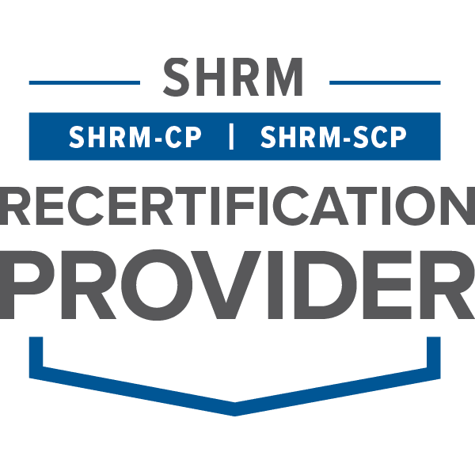

The Greater Kansas City Employee Benefit Professionals Association is recognized by SHRM to offer Professional Development Credits (PDCs). For more information about certification or recertification, please visit the SHRM website at www.shrm.org.

